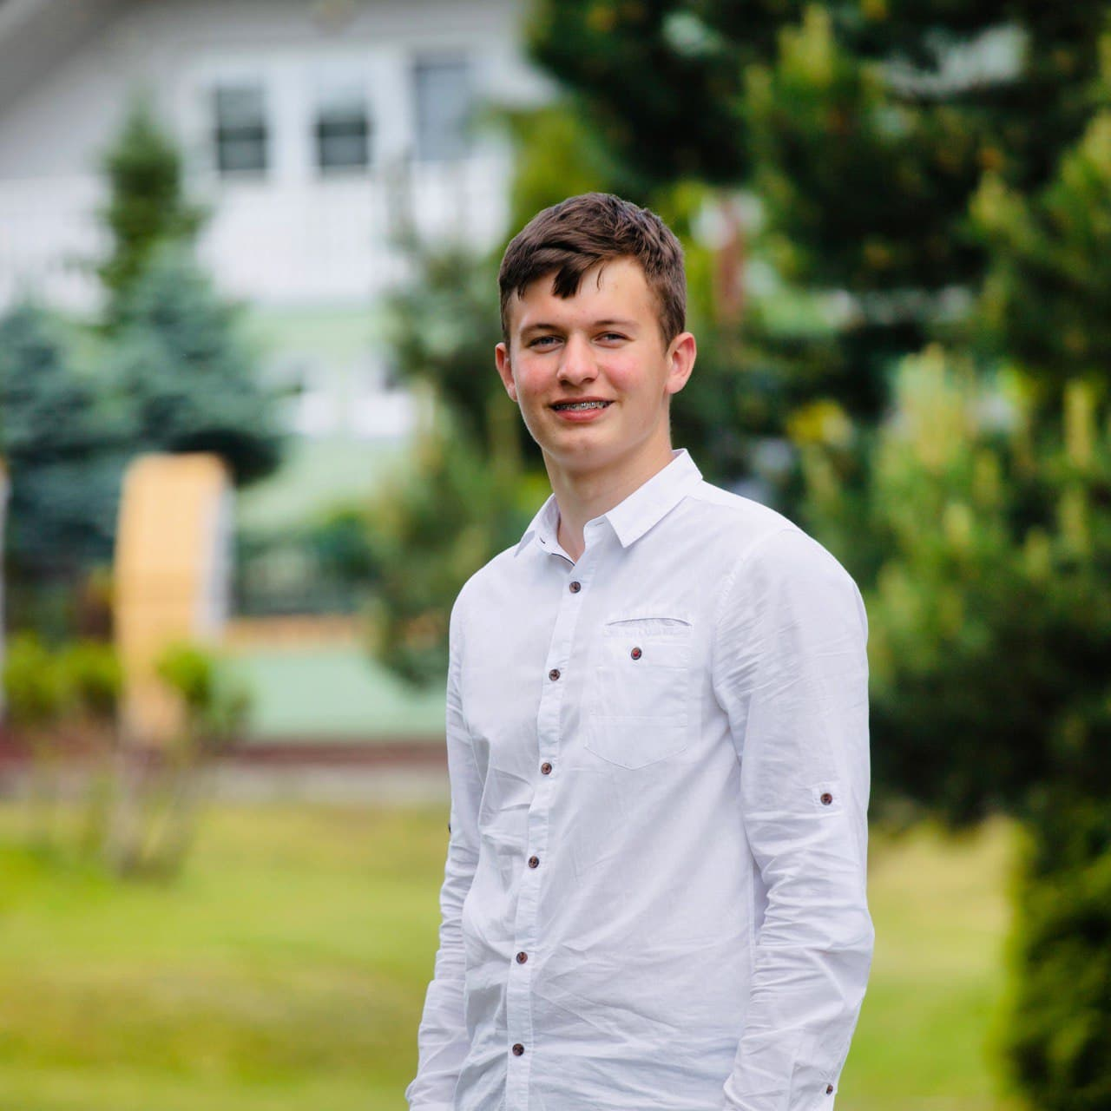

Contact information

|  |  |  |  |  |
| --- | --- | --- | --- | --- |
| Phone: +380972719041  Email: maks.abbiy.2019@gmail.com | | | Maksym Babii | |
|  | | C# developer | | |
|  | | | | |
| Summary of Qualifications | I am a second-year student at Lviv Polytechnic University. Actively studying OOP and have skills in developing windows-forms. You can see my works on git hub. | | | |
|  | | | | |
| **Skills** | C#, C++, Python, JavaScript, Linux | | |  |
|  |  | | | |
|  |  | | | |
|  |  | | | |
|  |  | | | |
|  |  | | | |
|  |  | | | |
| Languages | English pre-intermediate | | | |
|  | | | |
|  | | | |
|  |  | | | |
| Education | Lviv Polytechnic University, 2 course | | | |
|  | | | |

|  |  |  |
| --- | --- | --- |
| Additional education (courses, trainings) | Courses Okten Web University(Python) | |
|  | | |
| Hobbies | Volleyball, football, music |  |